Programming II Final Project Report
Weatherly
JavaFX Weather Application
Student Name | MHD Muhannad Alshatti
Student ID | 25120102062
Course | Programming II
Technology | Java, JavaFX, Maven
GitHub Link | https://github.com/muhannad2000/Weatherly

This report describes the design, implementation, features, and testing of the Weatherly JavaFX project.

1. Project Overview
Weatherly is a JavaFX desktop weather application that allows users to register, log in, and search for real-time weather information by entering a city name. The application displays the current temperature and wind speed using an online weather API.
The project also includes a clean graphical user interface with glass-style cards, dynamic background images based on temperature, and an animated wind fan that changes its rotation speed depending on wind speed. In addition, the application can optionally detect the user’s approximate current city using an IP-based location service.
The main purpose of this project is to create a visual JavaFX application that combines user authentication, file processing, API usage, event handling, and interactive user interface design.

2. Project Objectives
- Design and implement a JavaFX visual desktop application.
- Allow users to create accounts and log in.
- Save registered user data locally using file processing.
- Fetch real-time weather information from online APIs.
- Display temperature and wind speed in a clear interface.
- Improve user experience using dynamic backgrounds and animation.
- Add optional current location detection for easier weather searching.

3. Project Requirements Implementation

3.1 Basic Functions
The main function of Weatherly is to allow the user to search for weather information by entering a city name. After the user enters a valid city and clicks the search button, the application fetches live weather data and displays the city name, temperature, and wind speed.
The application also handles invalid city names. If the user enters an incorrect or unknown city name, the application shows an error message instead of displaying random weather data.

3.2 Authentication
Weatherly includes user registration, login, and logout. New users can create an account using the register screen. Existing users can log in using saved credentials. After a successful login, the user is taken to the main weather screen.

3.3 File Processing
The application uses local file processing to save registered users. When a new user creates an account, the username and password are saved in a local text file named users.txt. During login, the application reads this file and checks whether the entered username and password match a saved account.

3.4 Presentation and GitHub
The GitHub repository includes the source code, images, pom.xml file, README file, and instructions for running the project. This report explains the project design and implementation in detail.

4. Technologies Used
Technology | Purpose in the Project
Java | Main programming language for logic, file processing, API communication, and event handling.
JavaFX | Graphical user interface using Stage, Scene, Label, Button, VBox, HBox, and animations.
Maven | Project management and JavaFX dependency handling.
Open-Meteo API | Provides live weather data including temperature and wind speed.
IP-based location service | Detects the approximate current city using the internet connection.
GitHub | Stores and shares the project source code.

5. Application Screens and Screenshots

5.1 Login Screen
The login screen allows existing users to enter a username and password. If the information is correct, the user is taken to the main weather screen.
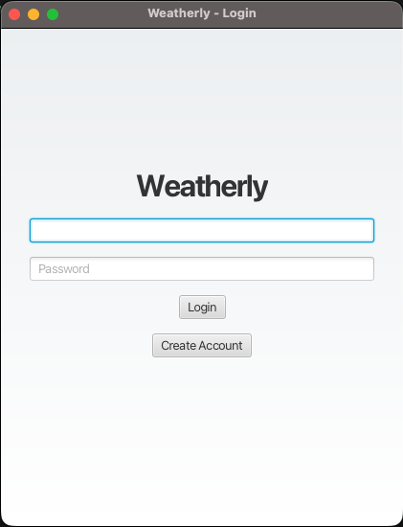
Figure 1: Login screen of Weatherly.

5.2 Current Location Alert
When the main screen opens, the application asks whether the user wants to use the current location. If the user accepts, Weatherly detects the approximate city based on the internet connection and automatically searches for its weather.
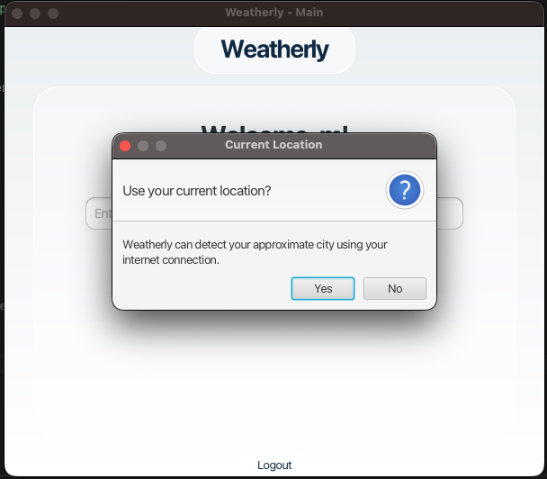
Figure 2: Optional current location confirmation alert.

5.3 Main Weather Screen - Chilly Example
The main screen uses glass-style cards to display weather and wind information. The background changes depending on the temperature range.
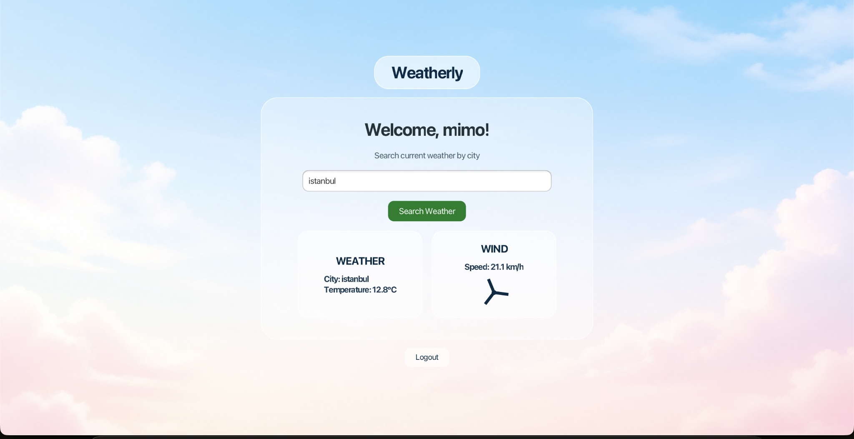
Figure 3: Istanbul weather result with chilly background.

5.4 Hot Weather Example
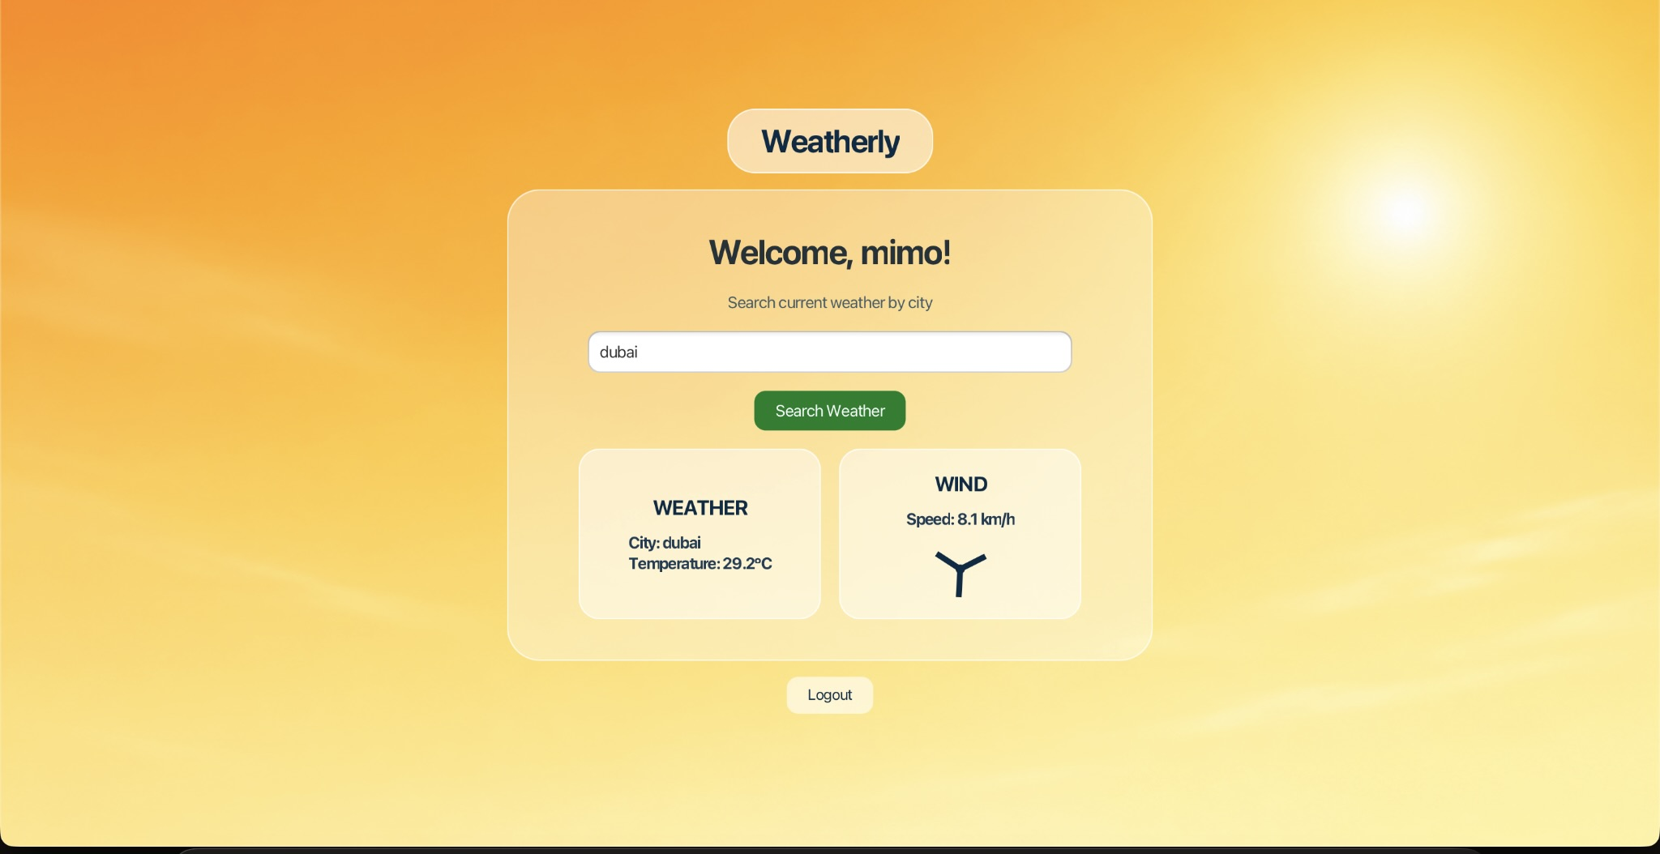
Figure 4: Dubai weather result with hot/warm background.

5.5 Cold and Very Cold Weather Examples
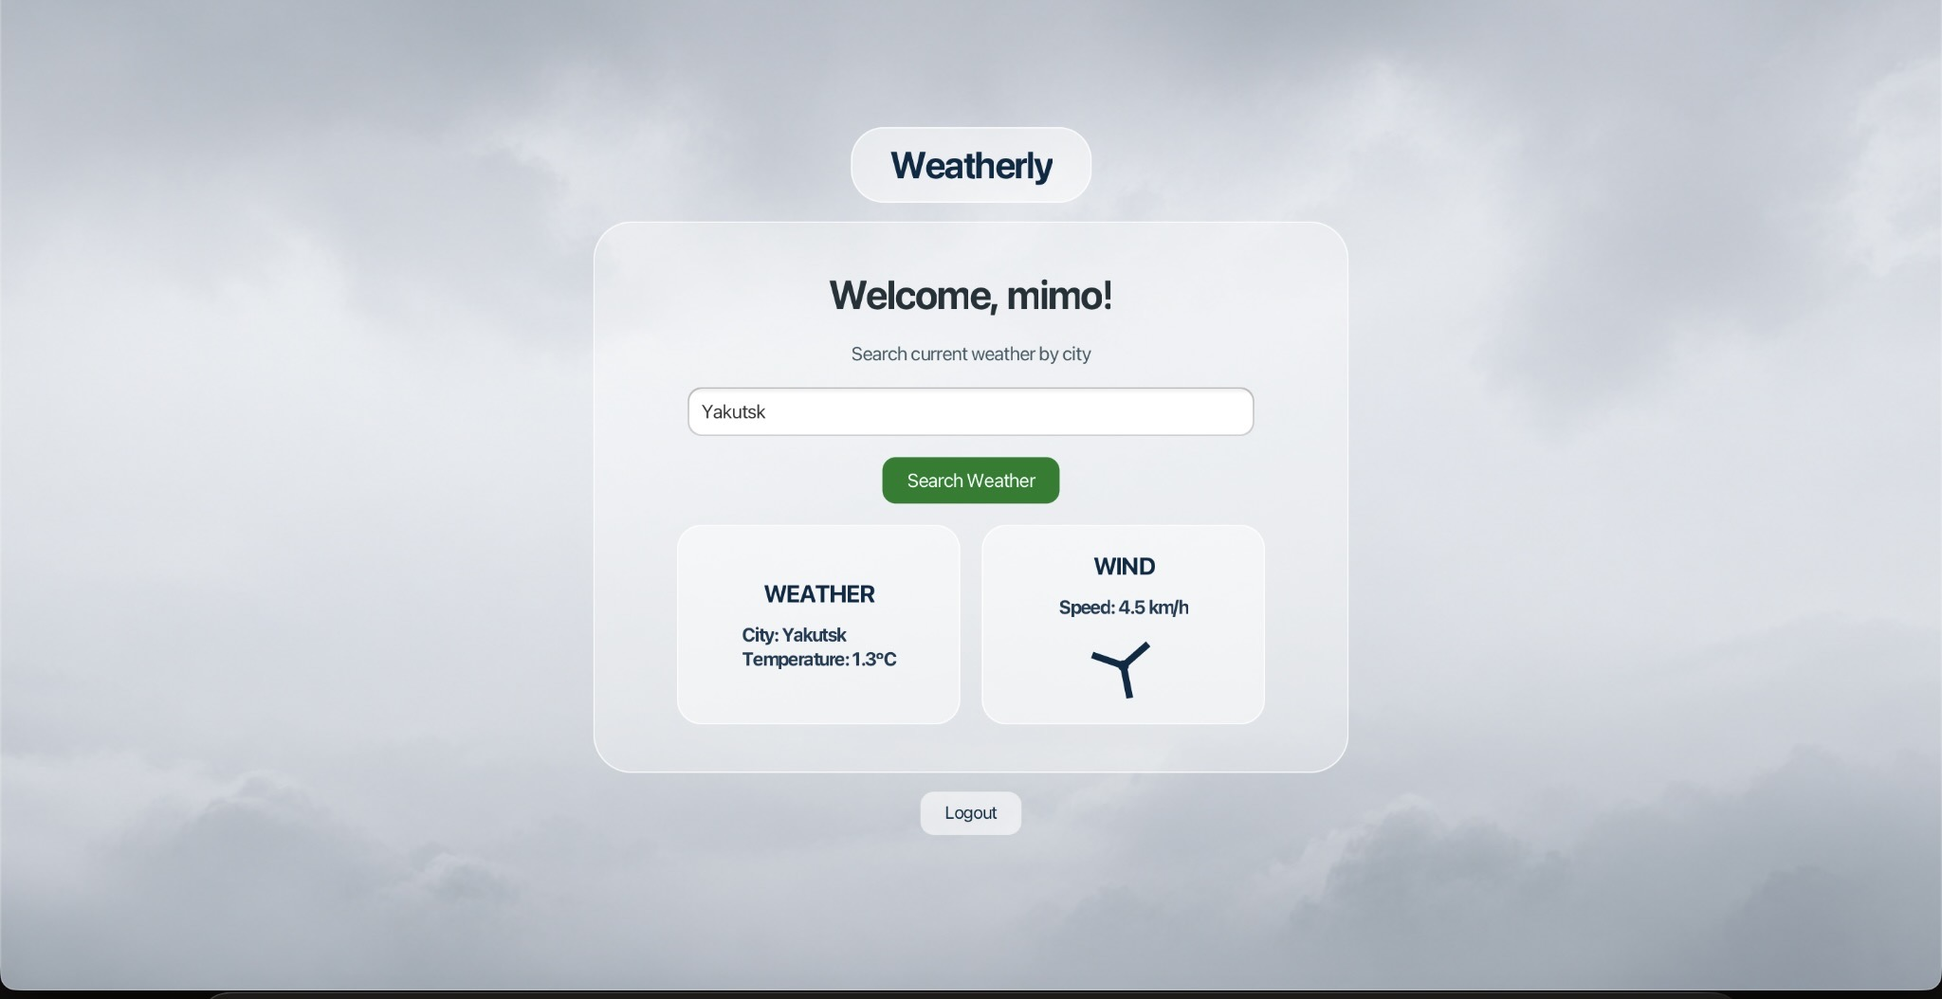
Figure 5: Yakutsk weather result with cold cloudy background.
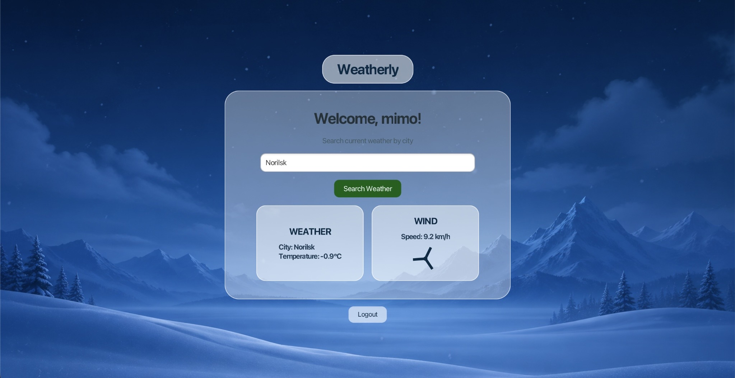
Figure 6: Norilsk weather result with very cold snowy background.

5.6 Invalid City Example
If the city cannot be found, the application displays a clear error message and does not show fake weather data.
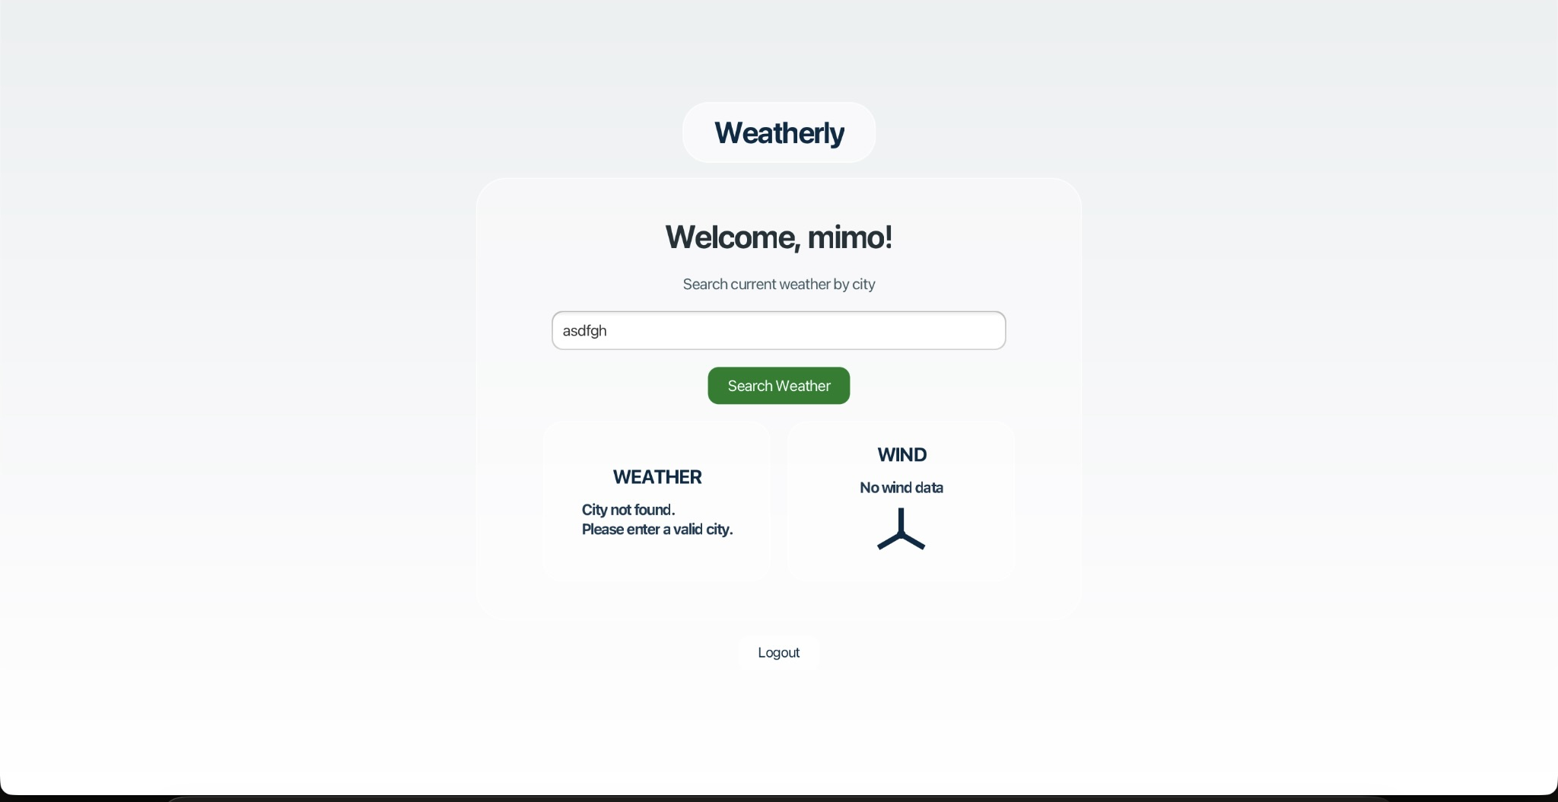
Figure 7: Invalid city example with error handling.

6. Implementation Details

6.1 Main.java
Main.java is the main JavaFX class. It starts the application, builds the login screen, register screen, main weather screen, and handles user interaction. It also controls background changes, wind fan animation, and current location detection.

6.2 Login and Register System
The login system reads saved accounts from users.txt and checks whether the entered username and password match an existing account. The register screen validates fields and writes new accounts into the same file using FileWriter.

6.3 Weather Search Logic
When the user clicks Search Weather, the application reads the city name from the text field and calls WeatherService.getWeather(city). If the service returns valid data, the application extracts temperature and wind speed and displays them in the interface.

6.4 Dynamic Backgrounds
The background image changes according to the temperature. Images are stored inside src/main/resources/images and are loaded through getClass().getResource().
- Below 0°C: Very cold background
- 0°C to 10°C: Cold background
- 10°C to 15°C: Chilly background
- Above 15°C: Hot/warm background

6.5 Fade Transition
FadeTransition is used to make background changes smoother. The screen fades slightly, changes the image, and then fades back in.

6.6 Wind Animation
The wind fan is drawn using JavaFX shapes such as Line and Circle. RotateTransition rotates the fan continuously. The duration of the rotation changes depending on wind speed, so stronger wind makes the fan rotate faster.

6.7 Current Location Feature
The current location feature is optional. It uses an IP-based location service to detect the approximate city. If a city is found, the application fills the city field and calls searchButton.fire() to automatically search for weather. This is not GPS-based, so the detected city is approximate.

7. WeatherService.java
WeatherService.java is responsible for connecting to online APIs and returning weather data to Main.java. It encodes the city name, gets latitude and longitude from the geocoding API, then uses those coordinates to request current weather data.
- Uses URLEncoder to prepare city names for URLs.
- Uses HttpURLConnection to send HTTP GET requests.
- Uses BufferedReader and StringBuilder to read responses.
- Uses simple string parsing to extract latitude, longitude, temperature, and wind speed.
- Returns City not found or Error fetching weather when needed.

8. Project Structure
Weatherly/
├── pom.xml
├── README.md
├── users.txt
├── src/
│ └── main/
│ ├── java/
│ │ └── com/weatherfx/
│ │ ├── Main.java
│ │ └── WeatherService.java
│ └── resources/
│ └── images/
│ ├── verycold.png
│ ├── cold.png
│ ├── chilly.png
│ └── hot.png

9. How to Run the Project
- Open the project in IntelliJ IDEA.
- Make sure Maven dependencies are loaded.
- Open the Maven tool window.
- Run Plugins > javafx > javafx:run.
If Maven is installed on the system, the project can also be run using:
mvn javafx:run

10. Conclusion
Weatherly successfully meets the requirements of the Programming II final project. It is a JavaFX visual desktop application that includes basic weather search functionality, user authentication, local file processing, live API data, and a clean graphical interface.
The project also includes extra visual features such as dynamic backgrounds, fade transitions, animated wind speed display, and optional current location detection. These features improve the user experience and make the project more complete and interactive.

